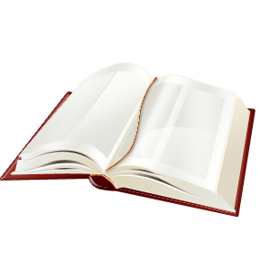
Reading Fair Timeline

Project Introduction at your school!
Week of September 19th
District Competition
October 25th
@GCPL
Individual School Competition
October 18th

